Sprint 1 - Endurance Design Document

March 28, 2022

Table of Contents

1. Executive Summary 3

1.1 Project Overview 3

1.2 Purpose and Scope of this Specification 3

2. Product/Service Description 3

2.1 Product Context 3

2.2 User Characteristics 3

2.3 Assumptions 3

2.4 Constraints 3

2.5 Dependencies 4

3. Requirements 4

3.1 Functional Requirements 5

3.2 Security 5

3.2.1 Protection 5

3.2.2 Authorization and Authentication 6

3.3 Portability 6

4. Requirements Confirmation/Stakeholder sign-off 6

5. System Design 6

5.1 Algorithm 6

5.2 System Flow 6

5.3 Software 6

5.4 Hardware 6

5.5 Test Plan 7

5.6 Task List/Gantt Chart 7

5.7 Staffing Plan 7

# Executive Summary

## Project Overview

This project’s goal is to program a Sphero robot to complete an endurance sprint. The robot must successfully travel around the periphery of HH208 (circumnavigate), change colors, and speak.

## Purpose and Scope of this Specification

It will start with a green light and speak ‘ready set go’ and stop with a red light and speak ‘I’m done and I need water’. It will travel to each of the yellow floor tiles and turn right at the center of each tile. It will return to its starting location. It will not collide with any objects as it goes around the room.

In scope

* Programming the Sphero robot to complete the endurance sprint (a rectangle)
* Programming the robot to change colors and speak

**Out of Scope**

* It won’t collide with anything

# Product/Service Description

Robot will start from the yellow square with blue tape. Robot will start with a green light and speak ‘ready set go’ and stop with a red light and speak ‘I’m done and I need water’. Robot will travel to each of the yellow floor tiles and turn right at the center of each tile. Robot will return to its starting location. Robot will not collide with any objects as it goes around the room.

## Product Context

This project contains many interfaces. Sphero is used to create the block code, excel is used to create the Gantt chart, and Word is used to create the documents. It is Sprint 1 of a 3 Sprint project.

## User Characteristics

* Student
* Experience with coding
* Experience with a Sphero robot

## Assumptions

The room HH208 must be available to run the course. A Sphero robot is needed, the Sphero coding app is needed, and coding experience is needed. Must be able to record the robot.

## Constraints

Describe any items that will constrain the design options, including

* Room size
* Sphero coding
* Room availability

## Dependencies

List dependencies that affect the requirements. Examples:

* The project needs to be tested before recording it
* The code needs to be completed before testing it

# Requirements

The robot must successfully travel around the periphery of HH208 (circumnavigate). A clear path will be provided from each outside wall. Robot will start from the yellow square with blue tape. Robot should start with a green light and speak ‘ready set go’ and stop with a red light and speak ‘I’m done and I need water’. Robot must travel to each of the yellow floor tiles and turn right at the center of each tile. Robot must return to its starting location. Robot should not collide with any objects as it goes around the room.

## Functional Requirements

| Req# | Requirement | Comments | Priority | Date Rvwd | SME Reviewed / Approved |
| --- | --- | --- | --- | --- | --- |
| ENDUR_01 | Start from yellow square with blue tape | Starting location | 1 | 3-7-22 | Approved |
| ENDUR_02 | Start with a green light | Starting color | 2 | 3-7-22 | Approved |
| ENDUR_03 | Start with speaking “ready set go” | Starting speech | 2 | 3-7-22 | Approved |
| ENDUR_04 | Stop with a red light | Stopping color | 2 | 3-7-22 | Approved |
| ENDUR_05 | Stop with speaking “I’m done and I need water” | Stopping speech | 2 | 3-7-22 | Approved |
| ENDUR_06 | Travel to each of the yellow floor tiles | Where it travels | 2 | 3-7-22 | Approved |
| ENDUR_07 | Turn right at the center of each yellow tile | Direction it turns | 2 | 3-7-22 | Approved |
| ENDUR_08 | Return to its starting location | Stopping location | 1 | 3-7-22 | Approved |
| ENDUR_09 | Do not collide with any objects | Cannot hit objects | 2 | 3-7-22 | Approved |
| ENDUR_10 | Complete it quickly | Quick and functions | 3 | 3-7-22 | Approved |

## Security

### Protection

Specify the factors that will protect the system from malicious or accidental access, modification, disclosure, destruction, or misuse. For example:

* encryption
* activity logging, historical data sets
* restrictions on intermodule communications
* data integrity checks

### Authorization and Authentication

Verifies identity of user.

## Portability

* Code is on one computer, can be shared
* Cost of robot
* Robot battery
* Use of block code
* Sphero application

# Requirements Confirmation/Stakeholder sign-off

|  |  |  |
| --- | --- | --- |
| Meeting Date | Attendees (name and role) | Comments |
| 03/07/22 | Gianna Rao: Project Manager | confirmed all |
| 03/07/22 | Christopher Morandi: Functional Manager | confirmed all |

# System Design

## Algorithm

Code:

Start

Set mainLED to green

Output: speak “Ready set go”

Roll 0 degrees at 65 speed for 10.2 seconds

Delay for 2 seconds

Roll 90 degrees at 62 speed for 6.2 seconds

Delay for 2 seconds

Roll 180 degrees at 60 speed for 11 seconds

Delay for 2 seconds

Roll 270 degrees at 63 speed for 6.5 seconds

Set mainLED to red

Output: speak “I’m done and I need water”

End

Test the code and record the robot

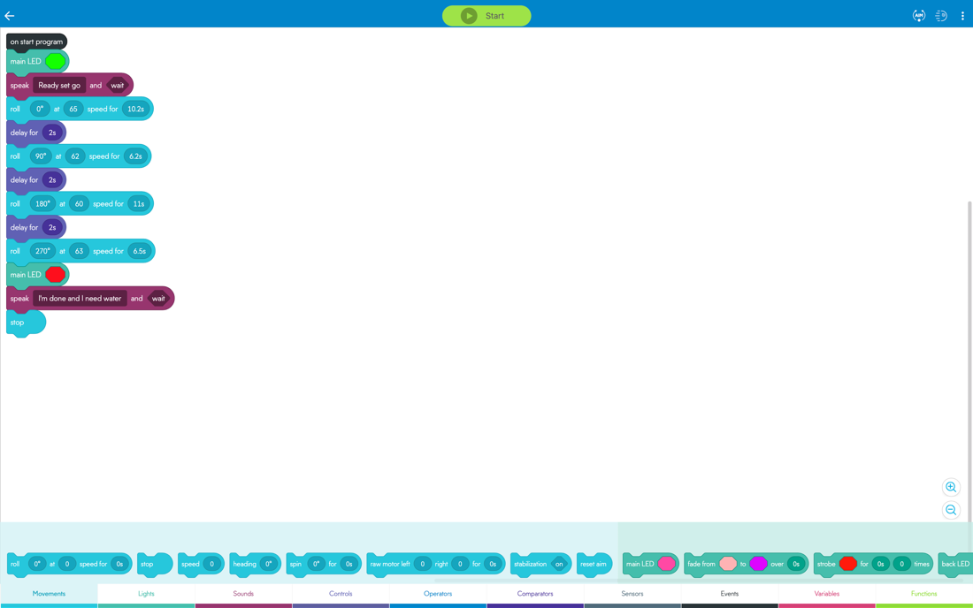

## System Flow

(next page)

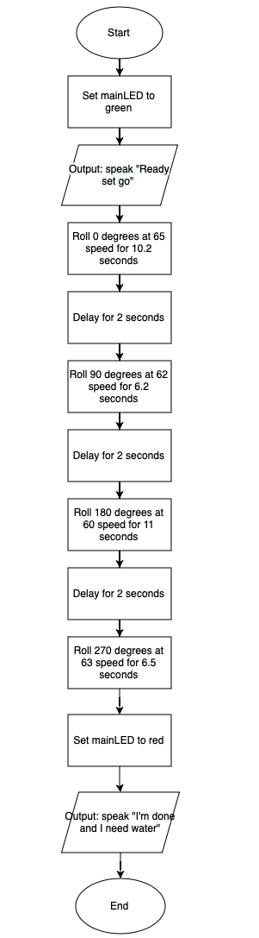

## Software

Sphero application and block code to program the Sphero robot.

## Hardware

MacBook Pro, iPhone to record, Sphero robot, room HH208’s course.

## Test Plan

Include a test plan showing all unit tests performed for this application, Include test rational, test date, staff member, pass/fail status

| **Reason for Test Case** | **Test Date** | **Expected Output** | **Observed Output** | **Staff Name** | **Pass/Fail** |
| --- | --- | --- | --- | --- | --- |
| Check if robot changes color correctly | 3-24-22 | Green at the start, red at the end | Green at the start, red at the end | Gianna Rao | Pass |
| Check if robot speaks correctly | 3-24-22 | Speaks “Ready set go” at the start and “I’m done and I need water” at the end | Speaks “Ready set go” at the start and “I’m done and I need water” at the end | Gianna Rao | Pass |
| Check if robot travels to each corner of the rectangle | 3-24-22 | Travels to each corner of the rectangle | Goes too far | Gianna Rao | Fail |
| Check if robot travels to each corner of the rectangle | 3-24-22 | Travels to each corner of the rectangle | Travels to each corner of the rectangle | Gianna Rao | Pass |
| Check if robot stops in the start location | 3-24-22 | Stops in the start location | Stops in the start location | Gianna Rao | Pass |

Sensor Data Diagram:

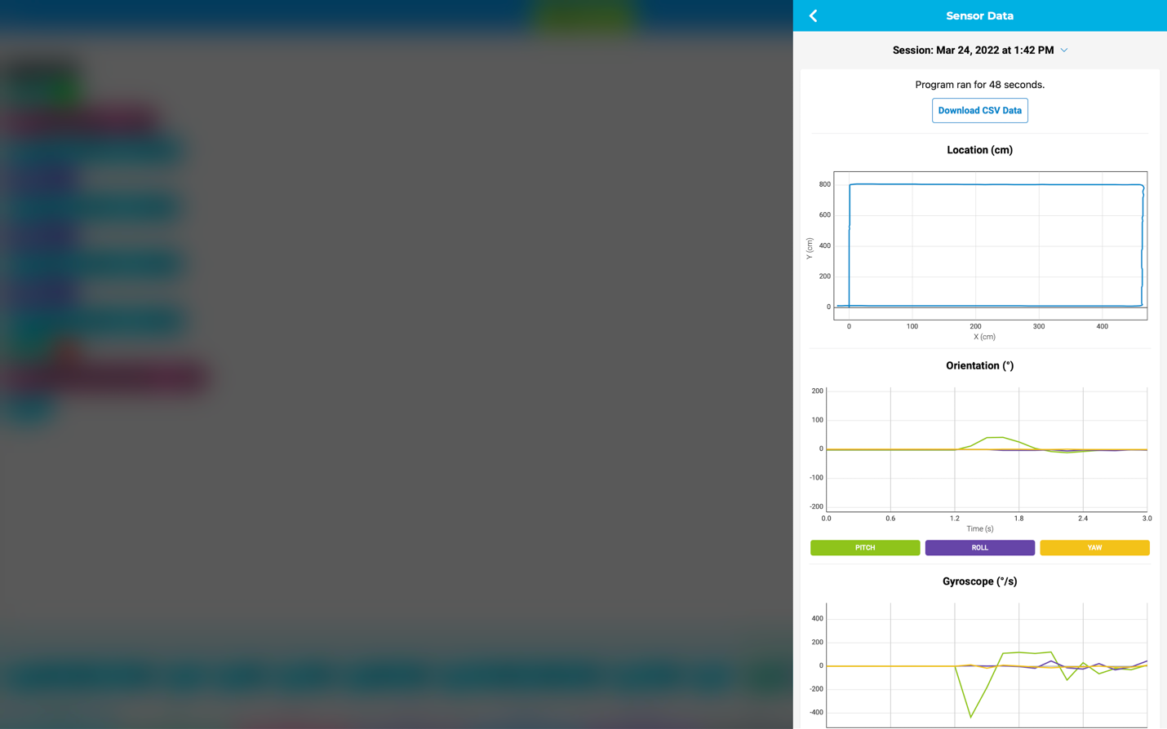

## Task List/Gantt Chart

## Staffing Plan

(next page)

| Name | Role | Responsibility | Reports To |
| --- | --- | --- | --- |
| Gianna Rao | Project Manager | Complete requirements of the project | Functional Manager |
| Christopher Morandi | Functional Manager | Make sure all requirements are completed | Project Manager |